Homework 3 Firewalls and VPN

- The UDP and ICMP protocols are not connection-based protocols, how do firewalls know whether a UDP or ICMP packet is part of an existing “connection”?
  - In stateful firewalls, the firewall checks if in-coming and out-going packets are part of an active connection. UDP and ICMP protocols, however, are not connection oriented, as opposed to TCP.
  - Stateful firewalls maintain a table labelled a “Connection state table” that keeps track of packets, or to “maintain [records] to understand the context of packets”. (slides)

- A machine has an IP address 10.0.20.5. On this machine, you need to block incoming connections to its ports 22, 23, 80, and 443. What will be the iptables command?
  - The iptables commands will be as such:
$ sudo iptables -A INPUT -p tcp –dport 22 DROP
$ sudo iptables -A INPUT -p tcp –dport 23 DROP
$ sudo iptables -A INPUT -p tcp –dport 80 DROP
$ sudo iptables -A INPUT -p tcp –dport 443 DROP

- A TCP server is running on a remote machine called sirius using "nc -lv 9090" (recall this command from the TCP chapter). This machine is on a planet outside the Solar system. An alien named Alice living on the Earth wants to communicate with the TCP server on sirius, but unfortunately, the Earth has a firewall that prevents all computers on the Earth from accessing any machine outside the Solar system. Alice does have a computer on Mars, which does not have such a restrict firewall rule. Alice’s computer on Mars is called mars, and her account name is called alien. Please describe how Alice can use an SSH tunnel to bypass Earth’s firewall, so she can talk to sirius.

  - The port used in the local host machine should be 8080. Why not port 80? (check online)
    - “Port 80 manages standard HTTP traffic, making its security critical for web applications.” - https://nordvpn.com/cybersecurity/glossary/port-80/
    - This means that they should use an open port that will not affect the primary web port. Port 8080 is actually known for being a test port that is an alternative to “testing applications locally without affecting the primary web server.” - https://itexus.com/port-8080-understanding-its-role-and-common-uses-in-networking/

  - What command should Alice run to set up the SSH tunnel?
    - The command should be as such:
$ ssh -L 8080:sirius:9090 mars
This should allow us to SSH from our port 8080 to mars, and then from mars the packets should be sent to Sirius’s port 9090 (our final destination).

  - Without the firewall, if Alice wants to communicate with the TCP server on sirius, she can use the "nc sirius 9090" command. Now, with the SSH tunnel and the firewall, what command should Alice run to access the server?
    - The command should be as such:
$ nc localhost 8080
The original command given in the slides is for telnet, but as we are not going to port 23, we do not need to do this. So all we need to do is connect to our port 8080 to forward our packets through the SSH tunnel to siruis.

- To log into X University’s network, Bob needs to use a TLS-based VPN. After he has established a VPN tunnel between his machine and X University’s network (128.230.0.0/16), he checks the routing table on his computer. Here is what he sees: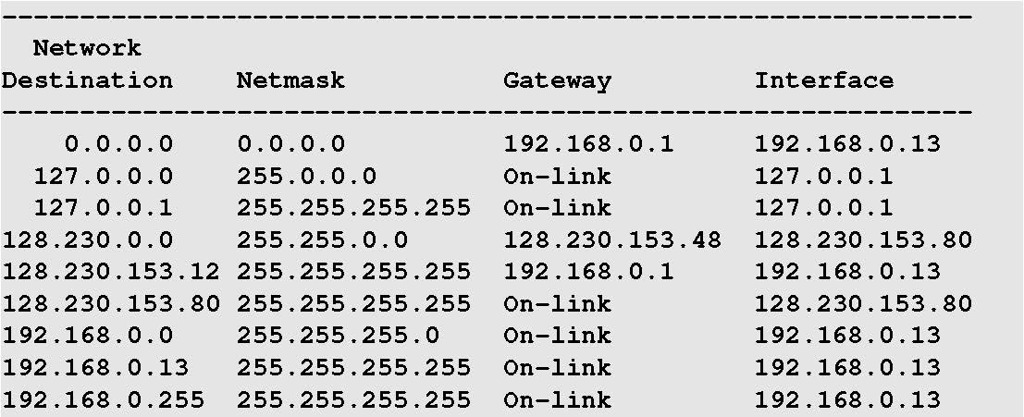
From the above routing information, please answer the following questions (you need to explain your answer).
  - What is the IP address of the TUN interface on Bob’s machine?
    - The IP address of Bob’s TUN Interface is 128.230.153.80
    - This is because the X University’s network is 128.230.0.0/16. The routing table should state that for any packet being sent to this subnet, it should be routed to the TUN. As such, looking at the network destination of 128.230.0.0 (with a mask of 16), the interface used is 128.230.153.80
  - What is the IP address of X University’s VPN server?
    - X University has a VPN Server with an IP address of 128.230.153.48
    - This is because the gateway used to go from the TUN interface (128.230.153.80) to the destination of the University’s network (128.230.0.0) must go through the gateway server which has the IP address of 128.230.153.48
  - What is the computer’s real IP address, i.e., the IP address assigned to the machine’s physical network interface card?
    - Bob’s IP address is most likely 192.168.0.13.
    - This interface is commonly used for a variety of destinations. Taking into account that this is the only address that makes sense in comparison to the rest of the addresses, my assumption that out of all the 192.168.0.0/16 addresses, the most specific (that isn’t all 1’s like 192.168.0.255) would be the IP address 192.168.0.13
  - Assume that Bob is behind a firewall that blocks him from accessing a web site (assume that the IP address of the web site is 8.8.8.8). Please describe how Bob can use X University’s VPN to bypass the firewall. If changes need to be made to this routing table, please show exactly what changes Bob needs to make to achieve the goal.
    - Since Bob already has a connection that can go outside of his firewall (his VPN connection to the University), he can utilize this.
    - Since we already know the IP address of the web site, all we need to do is add a rule to the routing table to simply push request through the tunnel. When a response is received on the University’s side, it will be sent back to him through the tunnel.
    - The command to add the specific routing entry is as follows:
$ sudo route add -net 8.8.8.8/32 tun0
If the TUN is not called tun0, then the actual IP address may need to be used:
$ sudo route add -net 8.8.8.8/32 128.230.153.80

